# ***LAB # 08***

*****Introduction to HTML (Continued)***

**Fall 2022**

**CSE101L Computer Fundamentals Lab**

Submitted by: **Haris Khan**

Registration No. : **60032**

Class Section: **A**

“On my honor, as student of University of Engineering and Technology, I have neither given nor received unauthorized assistance on this academic work.”

Student Signature: ______________

Submitted to:

**Engr. Abdullah Hamid**

January 02, 2023

Department of Computer Systems Engineering

University of Engineering and Technology, Peshawar

***Step #01:***

In the first step, I coded an html program in brackets.

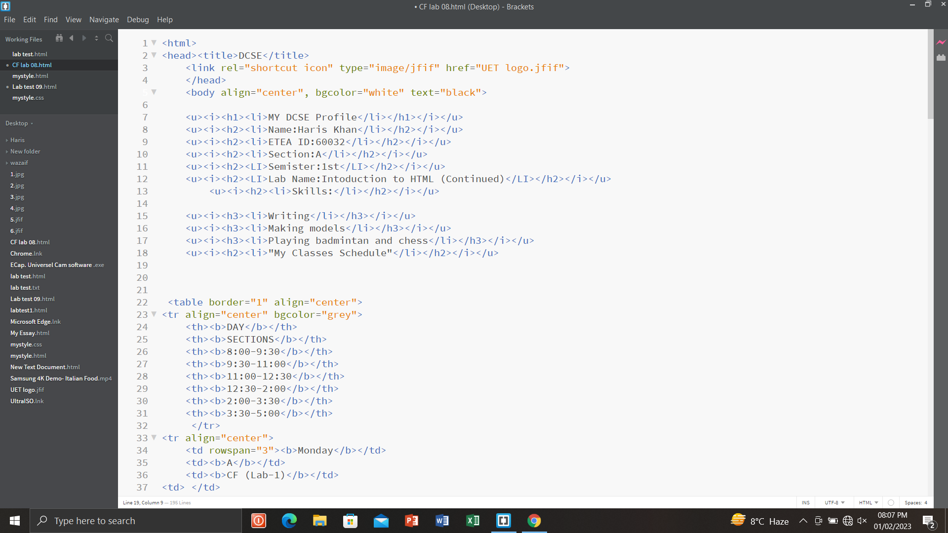

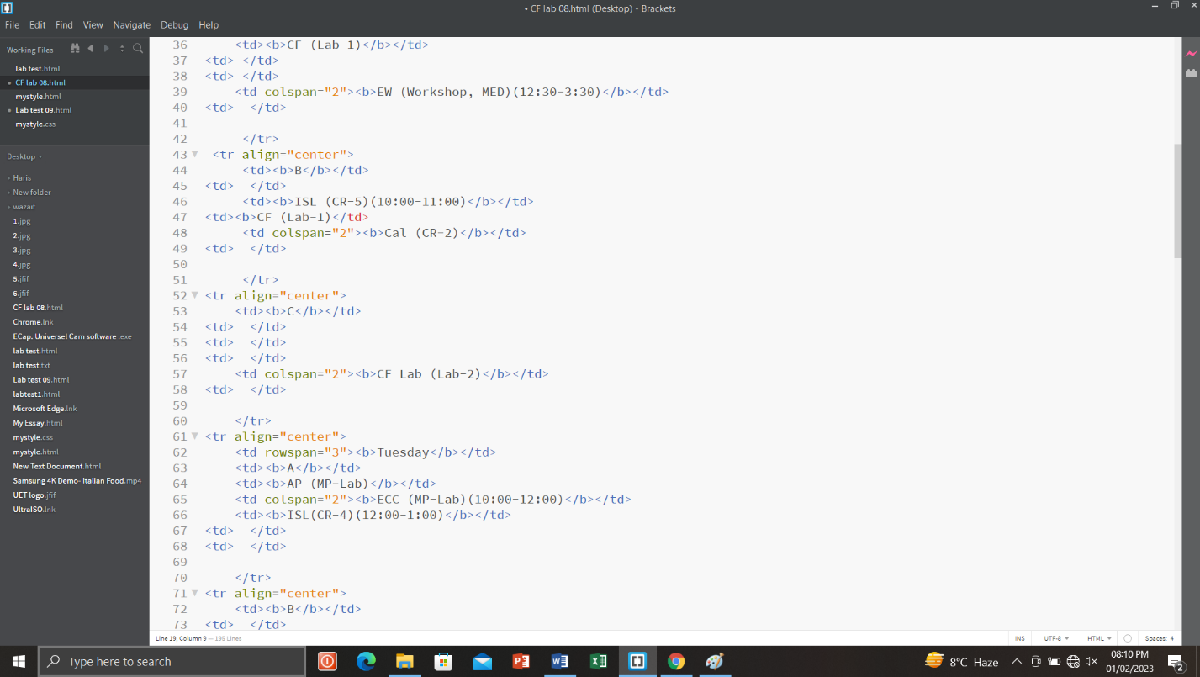

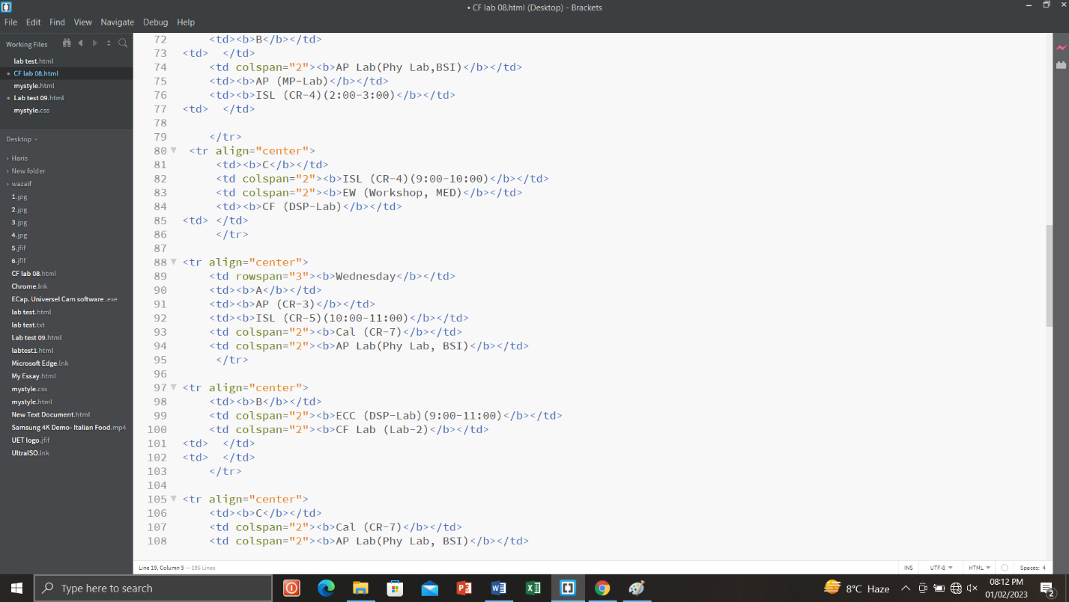

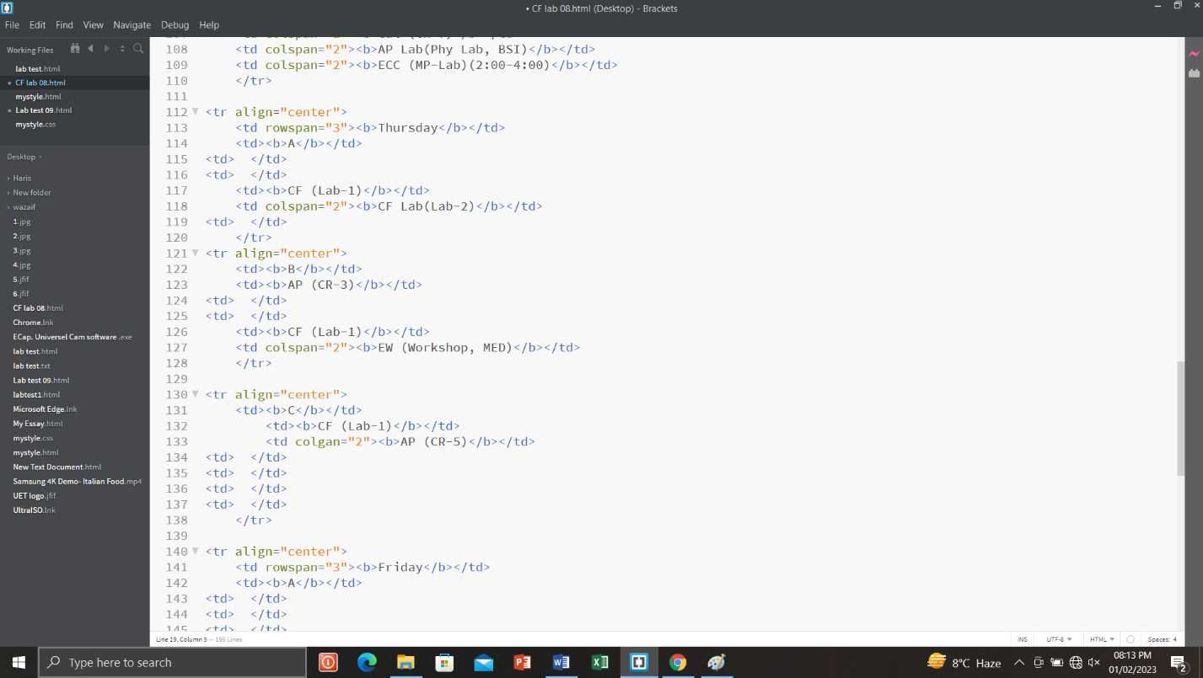

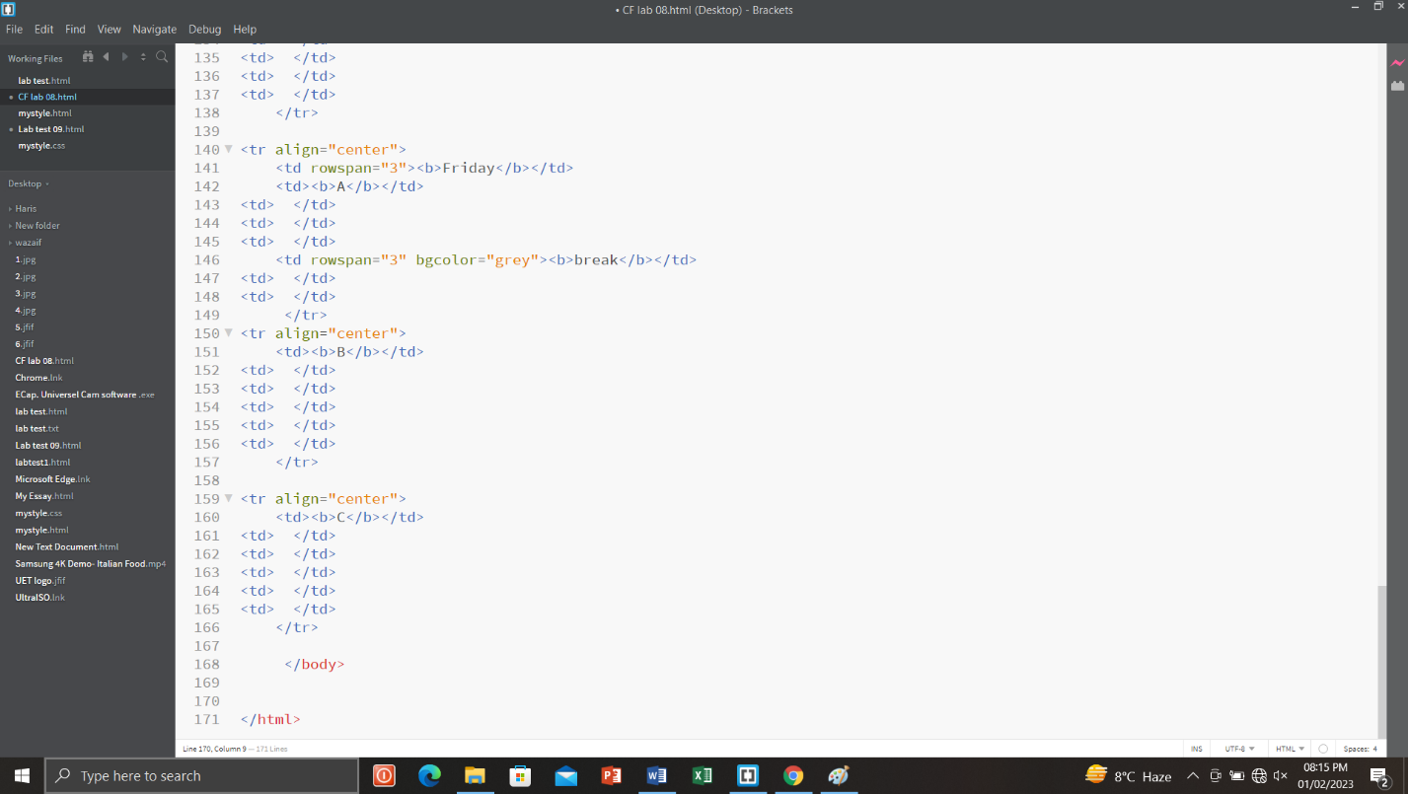

***Step #02:***

In the second step, I run the program coded in html.

